**Text Mining**

**Elon Musk Tweet Data**

* The provided data is in data frame format, we need to convert it first in corpus data.
* After cleaning the data and dtm matrix, following plots were obtained:

1. TF word cloud:

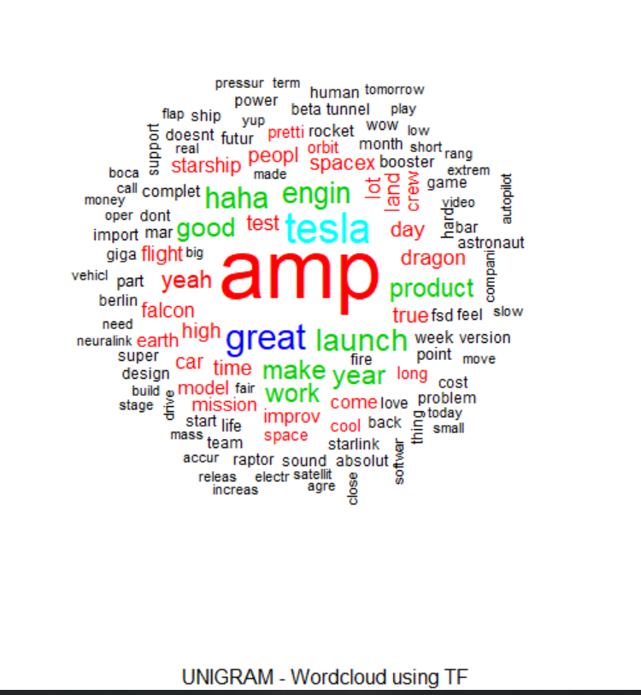

1. TF frequency plot:

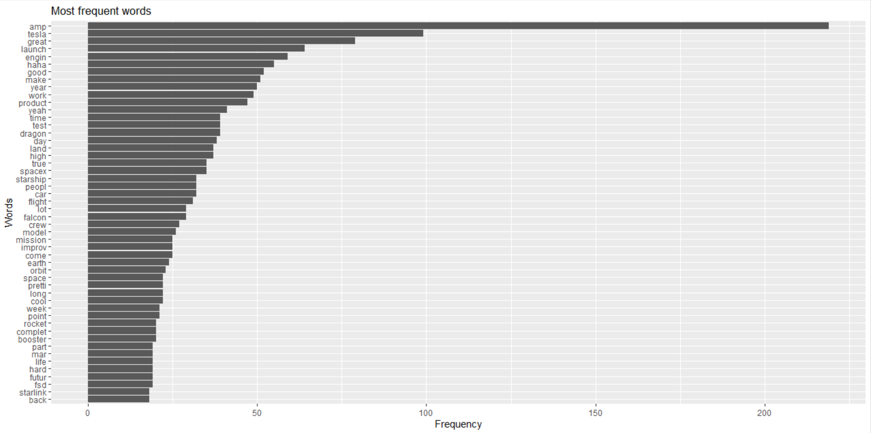

1. TFIDF word cloud:

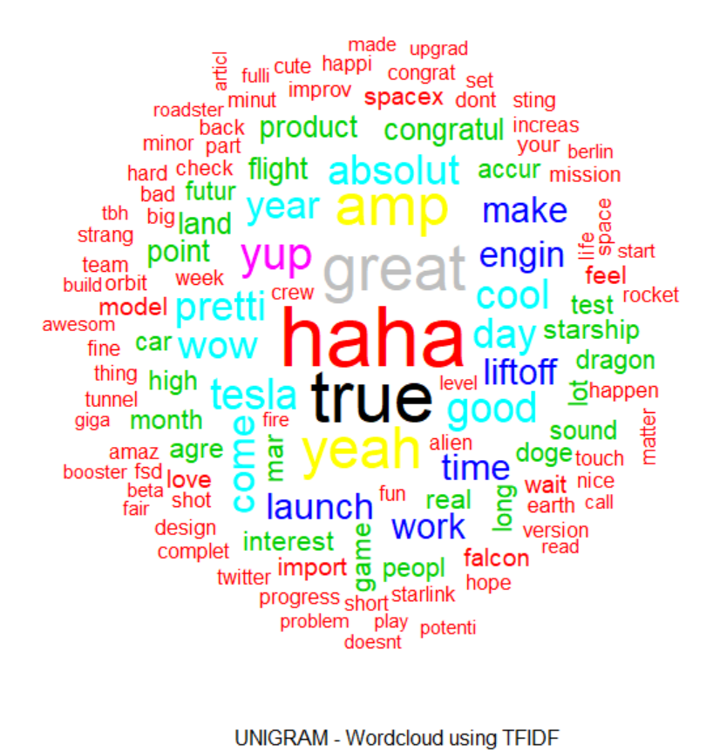

1. TFIDF frequency plot:

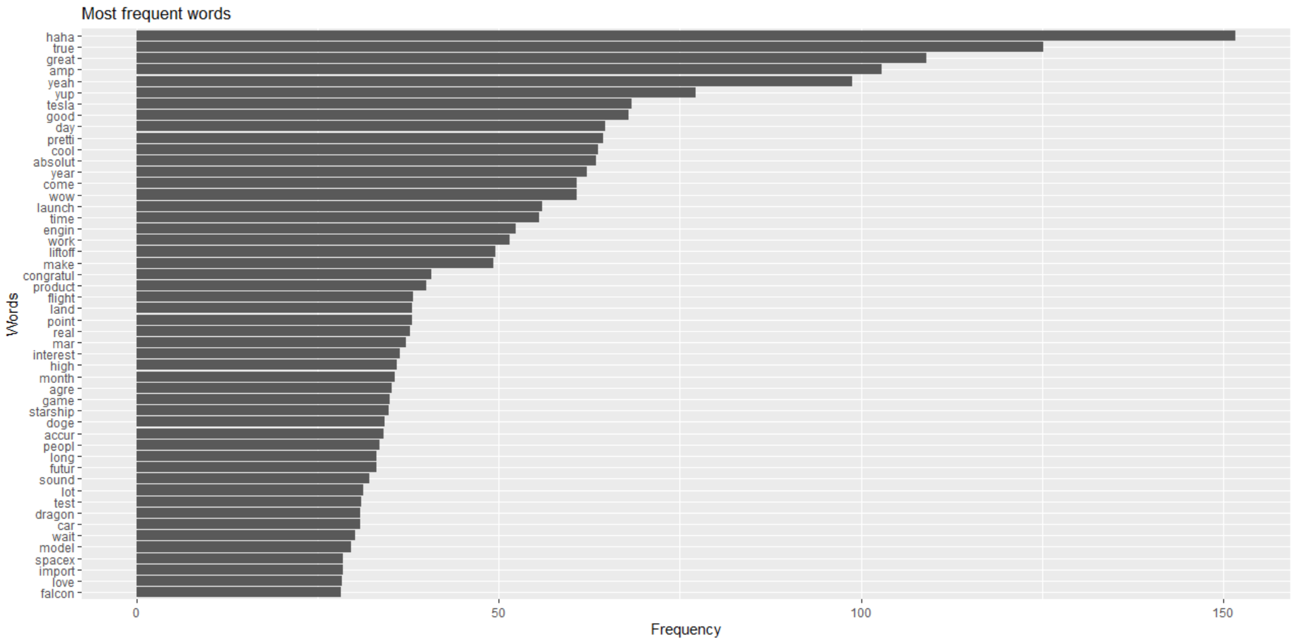

* Semantic Analysis: Performed semantic analysis using following methods:

1. Syuzhet: Achieved following result for 1st five observations

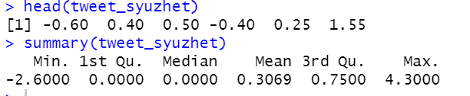

1. Bing: Achieved following result for 1st five observations

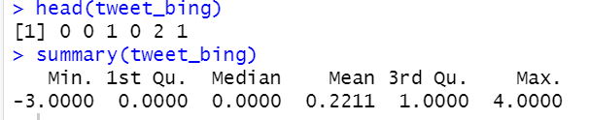

1. Afinn: Achieved following result for 1st five observations

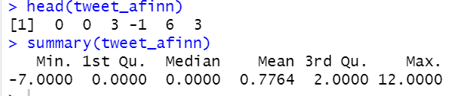

1. Comparison:

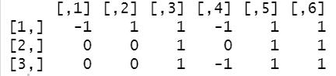

**Product Review Analysis**

* I have considered the “amazfit bip u” watch from Amazon for product review analysis.
* After cleaning the data and performing emotion mining, I got the following result:

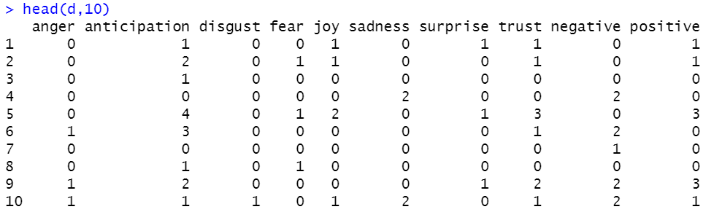

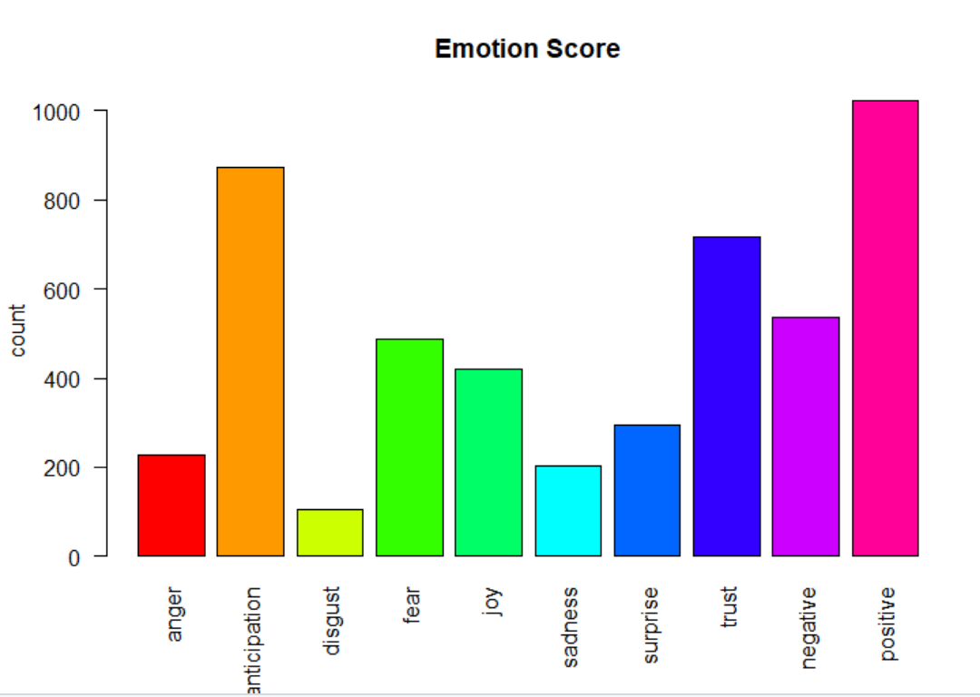

* Observing above plot we can infer that the product is being loved by the people, but along with it they demand for some more improvement, may be new features.
* On performing sentiment analysis, we can get the most negative scored sentence, which can help the company on working on their negative points:

“>  
[1] "Important note: The service of Amazfit is very bad and disappointing, they have only service center in ghaziabad and you have to send courier and pay 1589 <U+20B9> with return courier charges." “

* By getting the most positive sentence, the company can advertise on the features that the people like the most.
* The emotional valence graph can help us know how people are reacting:

